Component Templates & Interaction
In this exercise, you will
- Display data in a template
- Bind properties to the UI
- Handle user events
- Understand the core Angular template syntax

- Redo steps 1 to 11 from Exercise 03. But using project name as Ex04
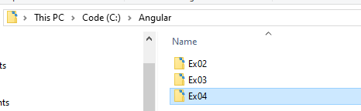

- Ex04 project in VS Code
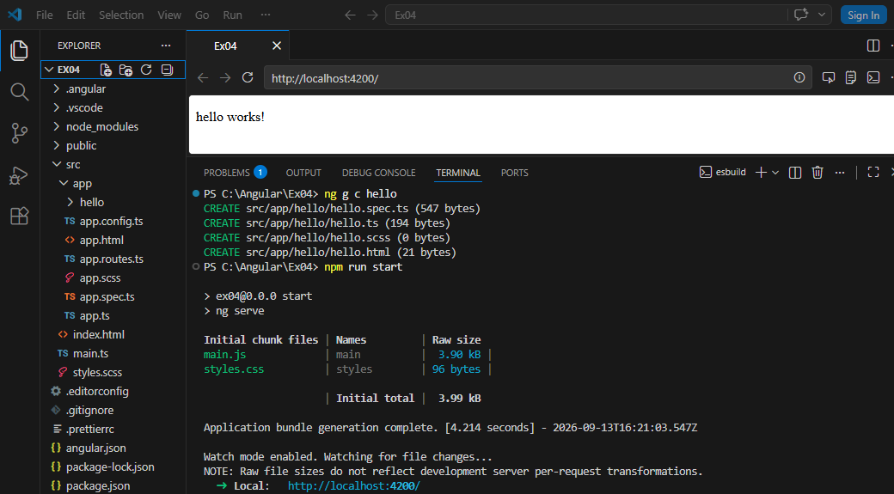

- In src/app/hello/hello.ts declare property title.
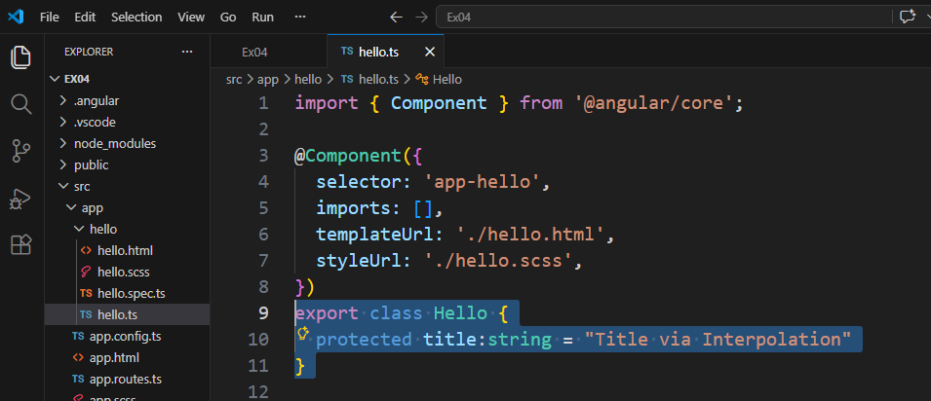
- In src/app/hello/hello.html, change to following
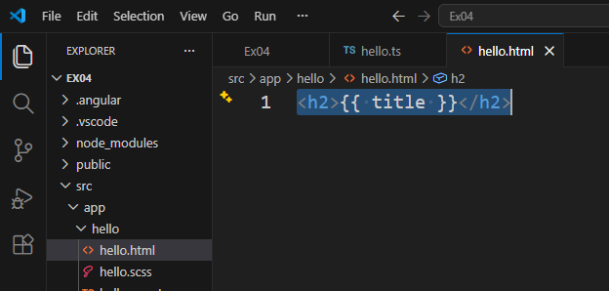

- Save all changes and go to Browser page. You should get the following
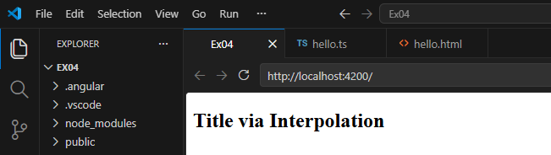

- In hello.html, add a new button with property “disabled” set to “true”
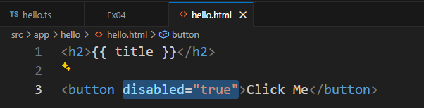

Save the file and go to browser page
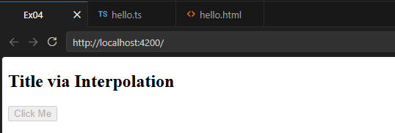

- In the hello.ts file, add a new property “isDisabled” with value “false”
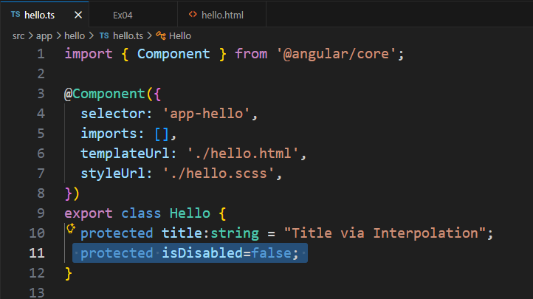

- In the hello.html file, do the following property binding
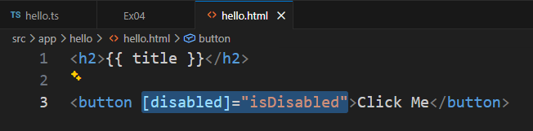

Save all files and go to browser page
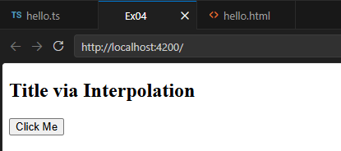
Now you should be able to click the button.

What do you think if we set the isDisabled property to false in hello.ts?

- In hello.ts, add a new onClick() function
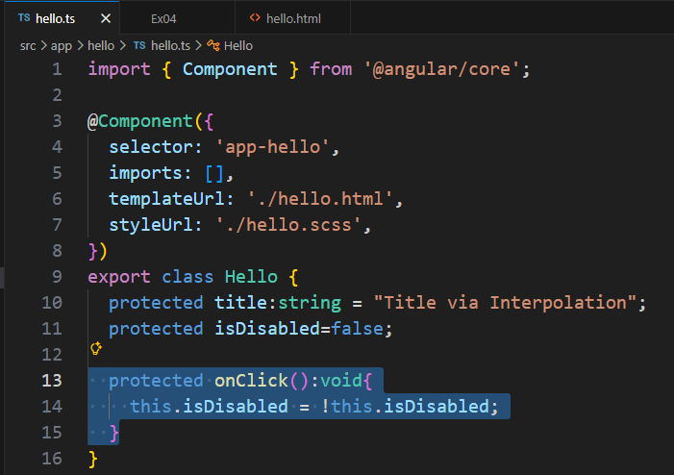
- In the hello.html, add an event binding for button
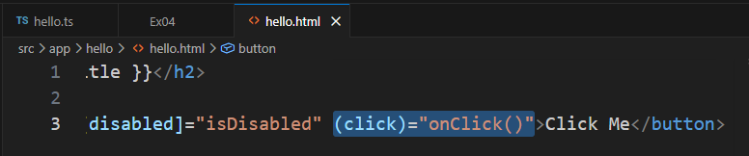

Save all files and go to browser page
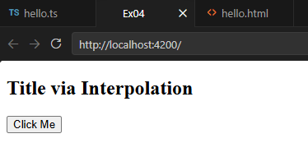
Try clicking the button

- Close VS Code

